Use case diagram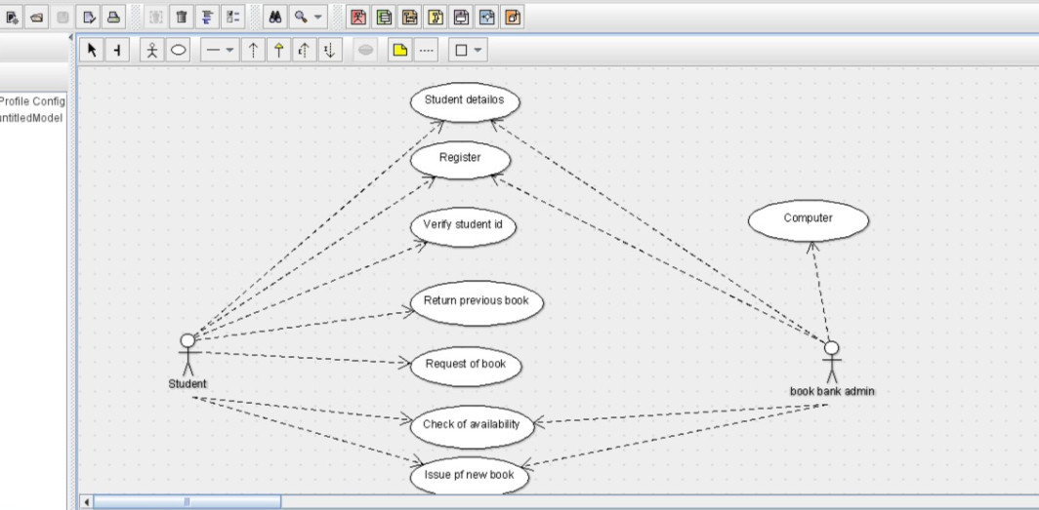

Class diagram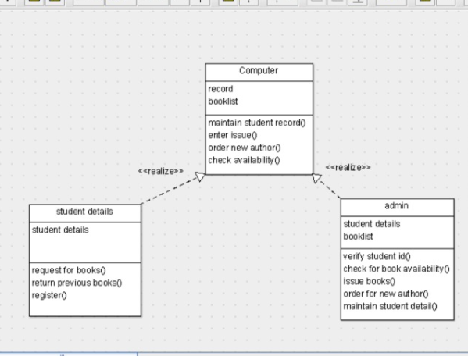

ACTIVITY DIAGRAM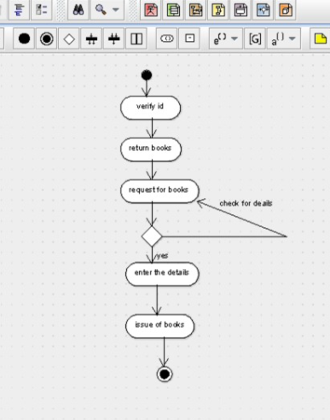

public class admin {

public student details;

public booklist;

public void verify student id() {

}

public void check for book availability() {

}

public void issue books() {

}

public void order for new author() {

}

public void maintain student detail() {

}

}

public class Computer {

private record;

public booklist;

public void maintain student record() {

}

private void enter issue() {

}

public void order new author() {

}

public void check availability() {

}

}public class student details {

public student details;

public ;

public void request for books() {

}

public void return previous books() {

}

public void register() {

}

}

Sequence diagram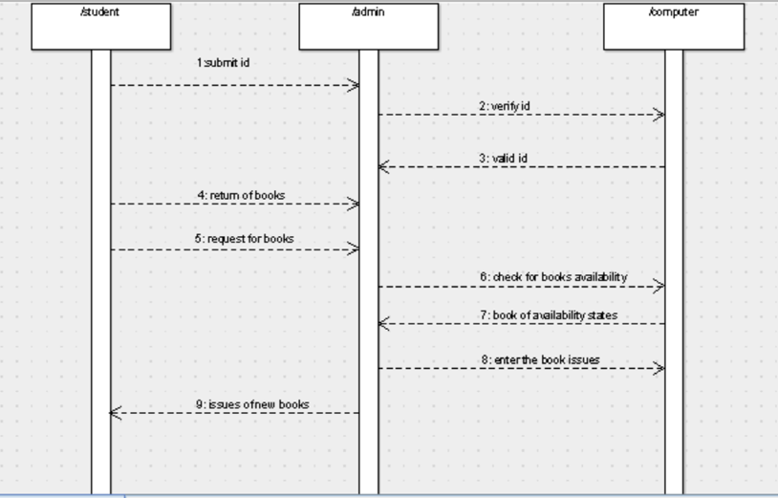

Collaboration diagram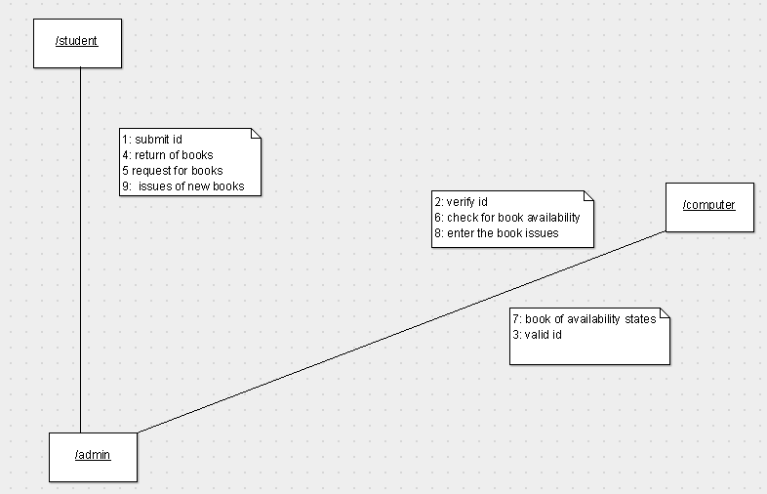

STATE CHART DIAGRAM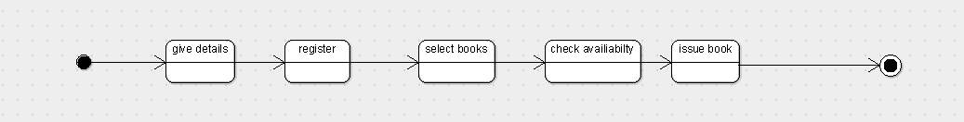

Component diagram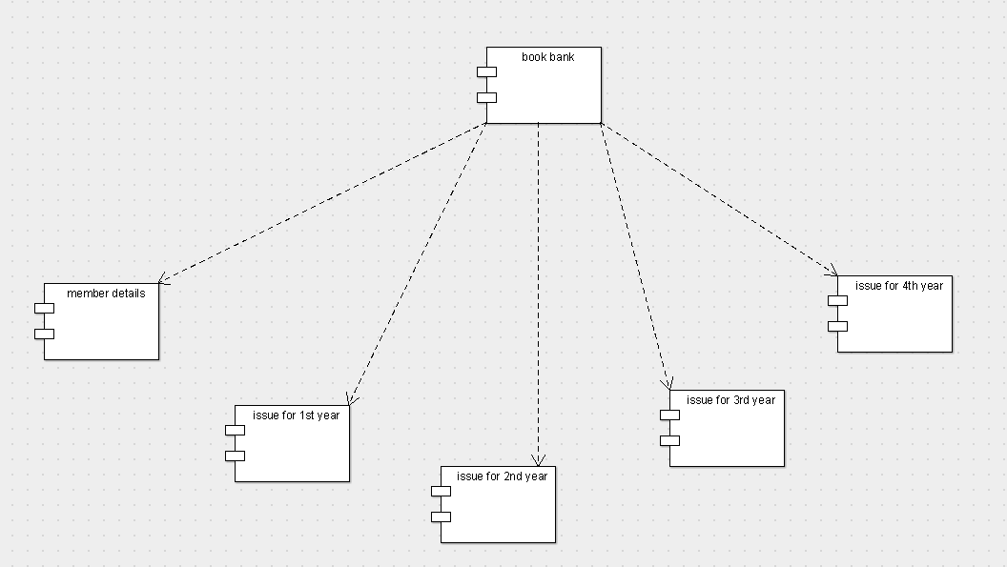

DEPLOYMENT DIAGRAM